|  |  |  |
| --- | --- | --- |
| **D:\PROJECT\rabiproject\DOCUMENT\images.jpg** |  | **docu0005** |

**A HYBRID PERSONALIZED RECOMMENDER**

**SYSTEM**

**A MINI PROJECT REPORT**

***Submitted by***

**NAME (2114112XXXX)**

***in partial fulfillment for the award of the degree***

***of***

**BACHELOR OF TECHNOLOGY**

***in***

**INFORMATION TECHNOLOGY**

**PANIMALAR ENGINEERING COLLEGE, POONAMALLEE**

**ANNA UNIVERSITY : CHENNAI 600 025**

**MAY 2021**

**ANNA UNIVERSITY: CHENNAI 600 025**

**BONAFIDE CERTIFICATE**

Certified that this project report **“--------------------------------------”** is the bonafide work of **“------------------- (211411205xxx) ”** who carried out the project under my supervision.

**SIGNATURE SIGNATURE**

**Dr. M. Helda Mercy M.E., Ph.D., Mrs. K.Lalitha M.E.,(Ph.d.,)**

**HEAD OF THE DEPARTMENT SUPERVISOR**

Associate Professor

Department of Information Technology Department of Information Technology

Panimalar Engineering College Panimalar Engineering College

Poonamallee, Chennai - 600 123 Poonamallee, Chennai - 600 123

Submitted for the project and viva-voce examination held on ______________

**SIGNATURE SIGNATURE**

**INTERNAL EXAMINER EXTERNAL EXAMINER**

**DECLARATION**

I hereby declare that the project report entitled “------------------------------” which is being submitted in partial fulfilment of the requirement of the course leading to the award of the ‘Bachelor Of Technology in Information Technology ’ in **Panimalar Engineering College, Affiliated to Anna University- Chennai** is the result of the project carried out by me under the guidance and supervision of **Mrs.K.Lalitha.M.E.,(Ph.D.,) Associate Professor in the Department of Information Technology**. I further declared that I or any other person has not previously submitted this mini project report to any other institution/university for any other degree/ diploma or any other person.

Date**:**

Place**:** Chennai (______________)

It is certified that this project has been prepared and submitted under my guidance.

Date: (**Mrs.K.Lalitha.M.E(P.hD.,))**

Place: Chennai (Associate Professor / IT )

**ACKNOWLEDGEMENT**

A project of this magnitude and nature requires kind co-operation and support from many, for successful completion . We wish to express our sincere thanks to all those who were involved in the completion of this project.

Our sincere thanks to **Our Beloved Secretary and Correspondent, Dr. P. CHINNADURAI, M.A., Ph.D.,** for his sincere endeavor in educating us in his premier institution.

We would like to express our deep gratitude to **Our Dynamic Directors , Mrs. C. VIJAYA RAJESHWARI and Mr. C. SAKTHI KUMAR, M.E.,** and **Mrs.saranya sree sakthikumar .,B.E.,M.B.A.,** for providing us with the necessary facilities for completion of this project.

We also express our appreciation and gratefulness to **Our Principal Dr. K. MANI, M.E., Ph.D.,**  who helped us in the completion of the project. We wish to convey our thanks and gratitude to our head of the department, **Dr. M. HELDA MERCY, M.E., Ph.D.,** Department of Information Technology, for her support and by providing us ample time to complete our project.

We express our indebtedness and gratitude to our staff in charge,  **Mrs.K.Lalitha, M.E(P.hD.,)** Associate Professor Department of Information Technology for his guidance throughout the course of our project. Last, we thank our parents and friends for providing their extensive moral support and encouragement during the course of the project.

**LIST OF TABLES**

|  |  |  |
| --- | --- | --- |
| **Table No.** | **Name of the Table** | **Page No.** |
| 6.3.1  6.3.2 | Test cases for Unit Testing  Test case Results | 79  79 |

**LIST OF FIGURES**

|  |  |  |
| --- | --- | --- |
| **Figure No.** | **Name Of the Figure** | **Page No.** |
| 3.1.1 | Proposed System Architecture | 23 |
| 3.2.1 | Process Data Flow Diagram For Clustering Phase | 24 |
| 3.2.2 | Process Data Flow Diagram For Filtering Phase | 25 |
| 3.3.2 | Agglomerative Clustering Algorithm | 27 |
| 3.3.5 | UML Class Diagram | 30 |
| 3.3.6 | UML Sequence Diagram For Clustering Phase | 31 |
| 3.3.7 | UML Sequence Diagram For Filtering Phase | 32 |
| 3.3.8 | UML Collaboration Diagram For Clustering Phase | 33 |
| 3.3.9 | UML Collaboration Diagram For Filtering Phase | 33 |
| 3.3.10 | UML Use Case Diagram | 34 |
| 5.2.1 | Screen Shot For Loading Dataset | 86 |
| 5.2.2 | Screen Shot Displaying Cluster Formation | 86 |
| 5.2.3 | Screen Shot Displaying Matrix Generation | 87 |
| 5.2.4 | Screen Shot For Login | 87 |
| 5.2.5 | Screen Shot For Searching | 88 |
| 5.2.6 | Screen Shot For Software Querying | 88 |
| 5.2.7 | Screen Shot which Displays Filtered Content | 89 |
| 5.2.8 | Screen Shot Displaying Predicted Result | 89 |
| 5.2.9 | Screen Shot Displaying Viewing Description | 90 |
| 5.2.10 | Screen Shot For Rating Item | 90 |
| 5.2.11 | Screen Shot which displays Posted Comment | 91 |
| 5.2.12 | Screen Shot For New User Registration | 91 |
| 5.2.13 | Screen Shot For New User Search | 92 |
| 5.2.14 | Screen Shot Displaying Recommendations for New User | 92 |

**LIST OFABBREVATIONS**

CF Collaborative Filtering

CBCF Cluster Based Collaborative Filtering

RSs Recommender Systems

PCC Pearson Correlation Coefficient

CBPCC Cluster Based Pearson Correlation Coefficient

MAE Mean Absolute Error

RMSE Root Mean Squared Error

KNN K nearest Neighbors

VSS Vector Space Similarity

HDFS Hadoop Distributed File System

PD Personality Diagnosis

AM Aspect Model

JSC Jaccard similarity coefficient

JSON Java Script Object Notation

HTML Hyper Text Markup Language

IDE Integrated Development Environment

**TABLE OF CONTENTS**

|  |  |  |
| --- | --- | --- |
| **CHAPTER NO.** | **TITLE** | **PAGE NO** |
|  | **ABSTRACT** |  |
|  | **LIST OF TABLES** |  |
|  | **LIST OF FIGURES** |  |
|  | **LIST OF ABBREVIATIONS** |  |
| **1** | **INTRODUCTION** | **1** |
|  | 1.1. OVERVIEW OF THE PROJECT | 2 |
|  | 1.2 PURPOSE OF THE PROJECT | 3 |
|  | 1.3 OBJECTIVE OF THE PROJECT | 3 |
|  | 1.4 SCOPE OF THE PROJECT | 4 |
| **2** | **LITERATURE SURVEY** | **5** |
|  | 2.1 A COLLABORATIVE FILTERING RECOMMENDATION ALG ORITHM BASED ON USER AND ITEM CLUSTERING | 5 |
|  | 2.2 CUSTOMIZATION OF RECOMMENDATION SYSTEM USING COLLABORATIVE FILTERING ALGORITHM ON CLOUD USING MAHOUT | 9 |
|  | 2.3 SCALABLE COLLABORATIVE FILTERING USING CLUSTER-BASED SMOOTHING  2.4 TOWARDS KEYWORD BASED RECOMMENDATION SYSTEM | 12  16 |
|  | 2.5 FEASIBILITY STUDY | 19 |
| **3** | **SYSTEM DESIGN** | **23** |
|  | 3.1 PROPOSED SYSTEM ARCHITECTURE DESIGN | 23 |
|  | 3.2 DATA FLOW DIAGRAM FOR PROPOSED SYSTEM | 24 |
|  | 3.3 MODULE DESIGN | 25 |
|  | 3.3.1. Job seeker module | 25 |
|  | 3.3.2. Recruiter module | 26 |
|  | 3.3.3. Administrator module | 28 |
| **4** | **REQUIREMENT SPECIFICATION** | **35** |
|  | 4.1 HARDWARE REQUIREMENTS | 35 |
|  | 4.2 SOFTWARE REQUIREMENTS | 35 |
|  | 4.2.1 Features Of Windows 7 | 35 |
|  | 4.2.2 Features Of Python Programming Language | 37 |
|  | 4.2.3 Features of Django  4.2.4 Features of Visual Studio Code | 39  42 |
| **5** | **IMPLEMENTATION** | **44** |
|  | 5.1 SAMPLE CODE | 44 |
|  | 5.1.1 Dataset Formulation | 44 |
|  | 5.1.2 Clustering Services | 51 |
|  | 5.1.3. Filtering Process | 56 |
|  | 5.1.4. Service Recommendation | 60 |
|  | 5.2 SAMPLE SCREEN SHOTS | 66 |
| **6** | **CONCLUSION AND FUTURE ENHANCEMENTS** | **68** |
|  | **REFERENCES** | **69** |

**INTRODUCTION**

**OVERVIEW**

Technology is constantly changing. Society as we know it depends on this fact. That which we take for granted today would have been the stuff of science fiction as little as fifty years ago. In fifty years, we will doubtless be excited, perturbed and baffled by yet more new developments. In the early years of the twenty first century, it is computers and the Internet that have captured the public imagination, and found their way into not just the working environments, but increasingly into the domestic spaces.

In this modern society, if we are not capable to cope up with these changes than we are not going to stand or survive anywhere in this technical world. Today there is no place for errors, so as to make a system more effective and efficient we need such technology where error prone chances must be least.

In the scenario of the assignment, we are required to develop a web-based application on Job Portal Management System. In this time of recession where everyone, is either experienced or fresher, is in search for a job. This job portal can prove to be very helpful since it allows users of different profile to upload their CVs, search job on the basis of their qualification. Every user can access through user id and apply for multiple jobs at a time.

Currently, we are working on a manual system where data is stored in the form of registers. Viewing available jobs or applying for the job at the agency can be done for which jobseekers has to go to the agency and check the available jobs at the agency. Job seekers check the list of jobs available and apply the job. Then the agency will show available jobs for the job seeker for his qualifications and then updates the jobs database. The developed Job Portal management system is web-based which Requires Employee Registration & Profiles, Job Search, Employer Registration & Profiles, and Subscription Option for both Employee and Employer etc. Employer can add Own Profile and post jobs and Job Seeker can Search Jobs based on Geographical Area (Country, State, and City), Qualification, and Company wise or on the Basis of Experience and Expertise wise.

**PURPOSE**

The purpose of designing the online job portal is to give the job seekers a platform for finding a right and a satisfactory job according to their qualification. It also connects the job seekers with the major agencies. It also provides Jobs portal for Job Seekers to submit their CV and apply for job posting and Employer can select best Employees from Available CV based on their payment option selection. This is basically a Job portal where job Seeker applies for jobs and employer post jobs and select prospective applicant. Job portal is prepared for provide all categories of job and help to get various type of job. The main purpose of job portal is to provide the facility to job seekers for getting the quick job. So, it enables applicants to search for jobs in a convenient manner and to enable employers to find suitable candidates.

**OBJECTIVE**

The objective of the application is to develop a system using which job applicants and recruiters can communicate with each other. An Online Job Portal is an application where the job seekers can register themselves at the website and search jobs which are suitable for them where as the employers register with the website and put up jobs which are vacant at their company. The Online Job Portal System is a package to be used by agencies to improve the efficiency of business. The Online Job Portal System to be developed benefits greatly the members. The system provides jobs catalogue and information to members and helps them decide on the jobs to apply. The Admin and employers can keep the jobs catalogue updated all the time so that the Job seekers get the updated information all the time.

**SCOPE**

The Scope for the system can be as follows:-

* Maintain Job Seeker and Employer records
* Maintain uploaded Resumes
* Provide Customized Job Postings
* Maintain Job Posting details and generate various reports

**SYSTEM DESIGN**

**PROPOSED SYSTEM**

The proposed system is a web based application which allows applicants and employers to register their details. Applicants can browse through the vacancy details that are posted and can apply for the jobs online. Employers can browse through the posted resumes and select suitable candidates.

• Filter, Search facility for job seekers according to their required vacancy.

• Daily updates via notifications and other communication media.

• Sending resume saves effort, time and cost of job seeker

• All vacancies are available on a single interface Job seeker can set privacy level for different companies

• Job seeker can save jobs according to their needs

• Most recent jobs are displayed on the home page

• Counting the number of times the resume of a job seeker is accessed by the company

• Ease of posting job vacancy by employer

• Ease of filtering applications that fit into eligibility criteria by scanning the resumes

• Ease of communication between job seeker and employer by internal messaging

• Easy generated reports

**ARCHITECTURE DESIGN**

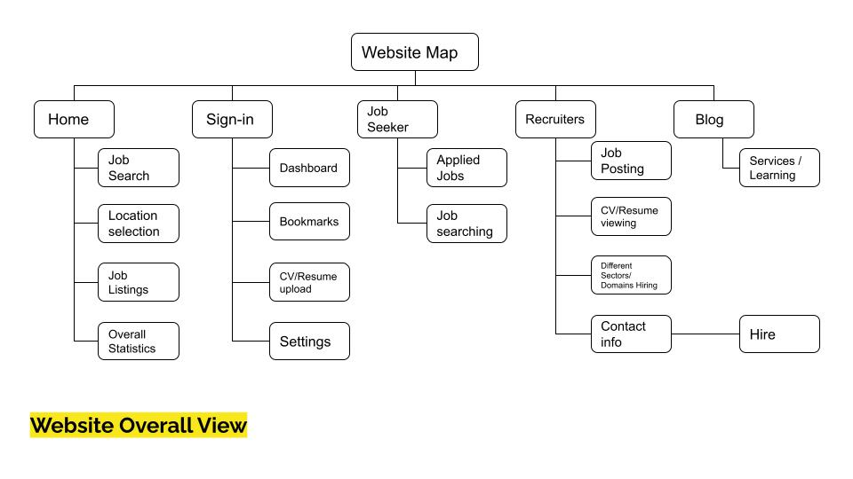

**DATA FLOW DIAGRAM**

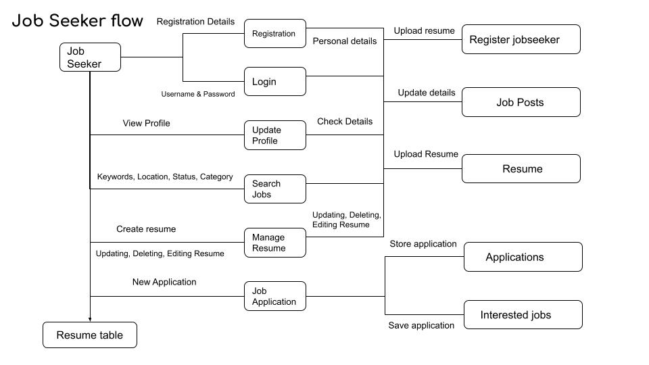

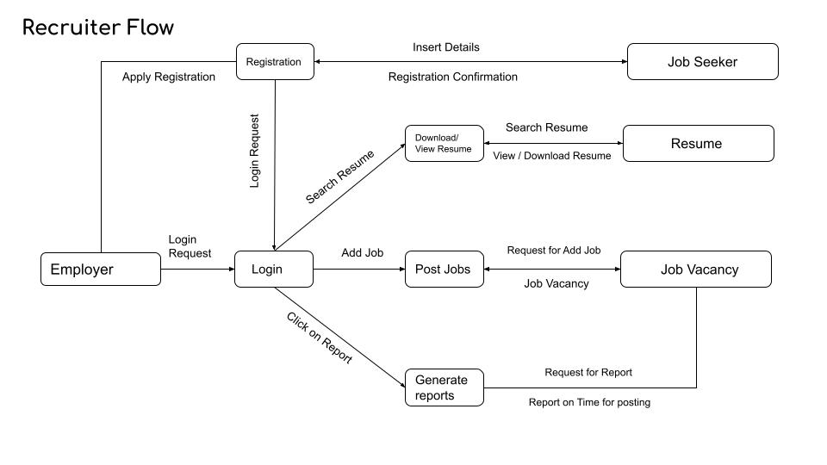

**MODULE DESIGN**

The application comprises the following major modules:

**Job Seeker Module**

This module provides functionalities for job seekers. Applicants can post their resumes with personal and professional details. They can also update the resume as frequently as required. The applicant can also browse through the present vacancies available. Job seekers can also get mail alerts when their resumes are selected by employers.

**Recruiter Module**

This module provides functionalities related to employers. Employers can post vacancy details and update the details as and when necessary. Employers can search through applicant resumes based on different criteria.

**Administration Module**

This module provides administrator related functionalities. Administrator manages entire application and maintains the profiles of applicants and employers.

**REQUIREMENT SPECIFICATION**

**HARDWARE SPECIFICATION**

Processer: Intel(R) Core(TM) i5-4570

Ram: 4 GB

Processor speed: 2 GHz

Hard Disk: 1 TB

Monitor: 1080 FHD Display

Keyboard: 104 Keys

**SOFTWARE SPECIFICATION**

Front End: HTML, CSS, JAVASCRIPT, BOOTSTRAP

Back End: PHP

Database: MYSQL

Interface: Chrome

Operating System: Windows 7 (Or) Higher

**FEATURES OF PYTHON**

**1. Easy to code:**

Python is a high-level programming language. Python is very easy to learn the language as compared to other languages like C, C#, JavaScript, Java, etc. It is very easy to code in python language and anybody can learn python basics in a few hours or days. It is also a developer-friendly language.

**2. Free and Open Source:**

Python language is freely available at the official website.

**3. Object-Oriented Language:**

One of the key features of python is Object-Oriented programming. Python supports object-oriented language and concepts of classes, objects encapsulation, etc.

**4. GUI Programming Support:**

Graphical User interfaces can be made using a module such as PyQt5, PyQt4, wxPython, or Tk in python.

PyQt5 is the most popular option for creating graphical apps with Python.

**5. High-Level Language:**

Python is a high-level language. When we write programs in python, we do not need to remember the system architecture, nor do we need to manage the memory.

**6. Extensible feature:**

Python is a Extensible language. We can write us some Python code into C or C++ language and also we can compile that code in C/C++ language.

**7. Python is Portable language:**

Python language is also a portable language. For example, if we have python code for windows and if we want to run this code on other platforms such as Linux, Unix, and Mac then we do not need to change it, we can run this code on any platform.

**8. Python is integrated language:**

Python is also an integrated language because we can easily integrated python with other languages like C, C++, etc.

**9. Interpreted Language:**

Python is an Interpreted Language because Python code is executed line by line at a time. Like other languages C, C++, Java, etc. there is no need to compile python code this makes it easier to debug our code. The source code of python is converted into an immediate form called bytecode.

**10. Large Standard Library**

Python has a large standard library which provides a rich set of module and functions so you do not have to write your own code for every single thing. There are many libraries present in python for such as regular expressions, unit-testing, web browsers, etc.

**11. Dynamically Typed Language:**

Python is a dynamically-typed language. That means the type (for example- int, double, long, etc.) for a variable is decided at run time not in advance because of this feature we don’t need to specify the type of variable.

**FEATURES OF DJANGO**

**1. Rapid Development**

Django was designed with the intention to make a framework which takes less time to build web application. The project implementation phase is a very time taken but Django creates it rapidly.

**2. Secure**

Django takes security seriously and helps developers to avoid many common security mistakes, such as SQL injection, cross-site scripting, cross-site request forgery etc. Its user authentication system provides a secure way to manage user accounts and passwords.

**3. Scalable**

Django is scalable in nature and has ability to quickly and flexibly switch from small to large scale application project.

**4. Fully loaded**

Django includes various helping task modules and libraries which can be used to handle common Web development tasks. Django takes care of user authentication, content administration, site maps, RSS feeds etc.

**5. Versatile**

Django is versatile in nature which allows it to build applications for different-different domains. Nowadays, Companies are using Django to build various types of applications like: content management systems, social networks sites or scientific computing platforms etc.

**6. Open Source**

Django is an open source web application framework. It is publicly available without cost. It can be downloaded with source code from the public repository. Open source reduces the total cost of the application development.

**7. Vast and Supported Community**

Django is one of the most popular web frameworks. It has widely supportive community and channels to share and connect.